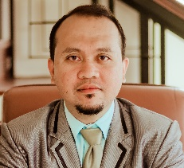**Virgilio O. Sio**

Poblacion, San Miguel Surigao Del Sur

[virgiliosio2010@gmail.com](mailto:virgiliosio2010@gmail.com)

0909-451-4680

**WORK EXPERIENCE**

Position **CSR**

Duration: June 2016 – November 2020

Company: **Conectys Philippines Inc.**

Company Industry: Call Center/ IT-enabled Services/BPO

Location: Filandia Bldg. 1 Qurino Ave. Davao City

Department: Customer Service

Job Description: Answer phone calls from customers

Position **CSR**

Duration: July 2013 – May 2016

Company: **West Contact Services/Alorica Inc.**

Company Industry: Call Center/ IT-enabled Services/BPO

Location: Gil Puyat Makati

Department: Customer Service

Job Description: Answer phone calls from customers

**EDUCATIONAL ATTAINMENT**

2005 – 2010 **Mindanao State University**

Marawi City

**BS Electrical Engineering**

5th Year Level

1999 – 2003 Agusan National High School

Butuan City

**TRAINING**

June 2013 – Sept. 2013 Global Communications Training

Global Communications & Management Academy

ePERFORMAX

May 6 – 18, 2013 Finishing Course for Call Center Agent

Mindbank and Skills Corporation